WEEK 6 REPORT
Tumour Region Localization Using Classical Image Processing
Digital Image Processing | BraTS2020 | BraTS20_Training_001 | Axial Slice 67

1. Objective
Week 6 focused on identifying which candidate region detected in Week 5 most likely corresponds to the tumour. The existing classical image-processing pipeline was reused, with one added localization rule based on connected-component area.

2. Dataset and Scope
The experiment used the FLAIR modality for patient BraTS20_Training_001, axial slice 67. The ground-truth segmentation mask was used for evaluation, with whole tumour defined as seg > 0. This report covers one slice only.

3. Methodology
- Preprocessing: Min-max normalization and 3×3 median filtering, reused from Week 5.
- Brain-region mask: Otsu thresholding, morphological opening, hole filling, largest connected component selection, and closing.
- Candidate-region detection: Otsu thresholding within the brain region, followed by morphological opening and closing and removal of components smaller than 50 pixels.
- Connected-component analysis: Calculate each retained component’s area, centroid, and bounding box.
- Localization rule: Rank components by area and select the largest component without using ground-truth overlap to make the selection.
- Evaluation: After selection, compare the localized prediction with the ground-truth mask.

4. Visualization
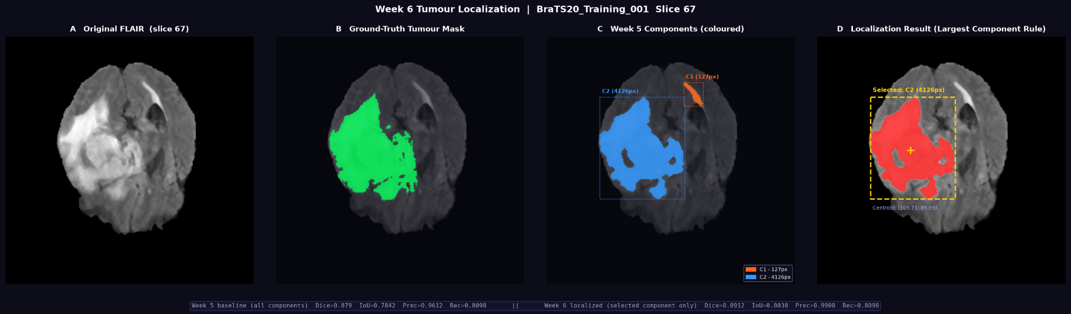
Figure 1. Original FLAIR slice, ground-truth tumour mask, Week 5 connected components, and Week 6 localization using the largest-component rule.

5. Connected Components
Component | Area (pixels) | Centroid (row, column) | Bounding box (min row, min col, max row, max col)
C1 | 127 | (55.24, 141.91) | (44, 132, 67, 151)
C2 | 4126 | (109.71, 89.59) | (58, 51, 157, 133)
The largest-component rule selected C2, with an area of 4,126 pixels and centroid approximately (109.71, 89.59). C1 had an area of 127 pixels.

6. Quantitative Results
Metric | Week 5 baseline | Week 6 localized
Dice | 0.8790 | 0.8912
IoU | 0.7842 | 0.8038
Precision | 0.9612 | 0.9908
Recall | 0.8098 | 0.8098
True positives (pixels) | 4088 | 4088
False positives (pixels) | 165 | 38
False negatives (pixels) | 960 | 960
Predicted area (pixels) | 4253 | 4126
For this slice, Dice increased from 0.8790 to 0.8912, IoU from 0.7842 to 0.8038, and precision from 0.9612 to 0.9908. Recall remained 0.8098. The localized mask contained 4,088 true-positive pixels and 38 false-positive pixels, with 960 false-negative pixels.

7. Interpretation
Selecting only the largest component removed the smaller candidate component from the prediction. This reduced false positives from 165 to 38 and increased precision. True positives and false negatives remained unchanged in the reported results, so recall did not change. The result supports the usefulness of this rule for this specific slice.

8. Limitations
- The largest-component rule is a heuristic and is not guaranteed to select the tumour on every slice.
- Other bright structures or artifacts can form large connected regions and may be selected incorrectly.
- Only one patient and one slice were evaluated, so general performance has not been established.
- The selected region is an algorithmic candidate, not a clinical diagnosis or verified tumour boundary.

9. Conclusion
Week 6 built on Week 5 by selecting the largest connected component from the existing Otsu-based candidate mask. For BraTS20_Training_001, slice 67, the localized prediction achieved Dice 0.8912 and IoU 0.8038, compared with baseline Dice 0.8790 and IoU 0.7842. Precision improved while recall stayed the same. Testing more slices is needed to determine whether the rule generalizes.

Appendix: Project Files
- week6_localization.png — four-panel visualization.
- week6_localization.csv — component-level measurements.
- week6_summary.md — experiment summary.
- week6_tumor_localization.py — Python implementation.

